**NATIONAL COMMUNICATIONS AUTHORITY**

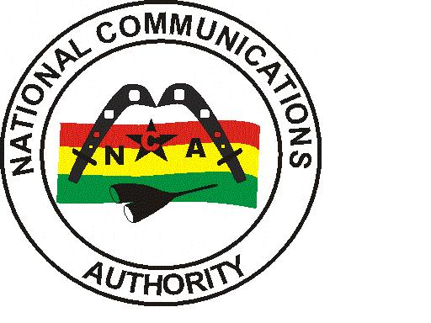

**MTN 3G COVERAGE REPORT – GREATER ACCRA REGION**

|  |
| --- |
| Test conducted | March-April 2022 |

**Contents**

List of Figures 1

List of Tables 1

1.0 EXECUTIVE SUMMARY 2

1.1 METHODOLOGY 2

1.2 FINDINGS AND ANALYSIS 3

1.2.1 Test Locations 3

1.2.2 Coverage Status 4

1.2.3 3G Coverage Plot 6

1.2.4 RSCP Sampling Distribution 13

1.3 CONCLUSION 14

## List of Figures

Figure 1. 3G Coverage Plot – Abokobi 6

Figure 2. 3G Coverage Plot – Adenta 7

Figure 3. 3G Coverage Plot – Amasaman 7

Figure 4. 3G Coverage Plot – Dansoman 8

Figure 5. 3G Coverage Plot – Dodowa 8

Figure 6. 3G Coverage Plot – Kokomlemle 9

Figure 7. 3G Coverage Plot – Kpone 9

Figure 8. 3G Coverage Plot – La 10

Figure 9. 3G Coverage Plot – Madina 10

Figure 10. 3G Coverage Plot **–** Nungua 11

Figure 11. 3G Coverage Plot **–** Prampram 11

Figure 12. 3G Coverage Plot **–** Sege 12

Figure 13. 3G Coverage Plot **–** Sowutuom 12

Figure 14. 3G Coverage Plot – Tema Community 1 13

Figure 15. 3G Coverage Samples Plot 13

## List of Tables

Table 1: Signal Strength Range 2

Table 2: 3G Coverage Assessment Schedule and Test Locations 3

Table 3: Coverage Status and Average Signal strength for each test location 4

## 1.0 EXECUTIVE SUMMARY

Clause 6.4 of Annex A of the 3G Licence directs the Licensee to roll-out 3G deployment across all Metropolitan, Municipal and District capitals of the country within five (5) years after the effective date of the Licence. In order to monitor and ensure compliance of coverage obligations, a 3G Coverage verification campaign was carried out from 11th March to 9th April 2022 in fourteen (14) District Capitals in the Greater Accra Region. The findings of the audit exercise revealed MTN’s 3G coverage presence in all fourteen (14) tested district capitals; with major coverage improvement required in Amasaman, Dodowa and Kpone.

## 1.1 METHODOLOGY

The methodology used in this exercise relied on field tests performed using NEMO INVEX II for data collection.

Measurement samples were collected in idle 3G-locked drive-test mode along pre-defined route within each district capital in the Greater Accra Region.

Network coverage assessment was made by measuring the downlink signal levels, CPICH RSCP (Common Pilot Channel Received Signal Code Power) for WCDMA/UMTS services.

The main indicators used for this exercise was based on parameters below:

* Signal Strength (dBm)
* Coverage Status

Generally, the signal strength as seen in NEMO WIND CATCHER is shown below:

Table 1: Signal Strength Range

|  |  |  |  |  |
| --- | --- | --- | --- | --- |
| Radio Access Technology | Signal Strength Range (dBm) | | | |
| WCDMA (3G) | -105>RSCP | –105≤ RSCP < -95 | –95≤ RSCP< –85 | –85 ≤RSCP < –20 |
| Rating | Non-existent | Poor | Fair | Good |

The essence of the idle 3G-locked mode of coverage sample collection was to obtain on the average a signal strength measurement which is representative of the coverage situation in each of the district capital that was driven.

A “**Not Covered**” coverage status is rated on the basis that either a “No WCDMA signal” was detected by the measurement system or the average RSCP level obtained was less than **-105 dBm** as stipulated under Section 1.5 of Annex A of the 3G Licence.

A “**Not Maintained”** coverage status is rated on the basis that even though a “No WCDMA signal” was detected or RSCP level obtained was less than -105 dBm, an independent analysis by the Authority confirmed that coverage had existed but was not maintained at the period of the drive.

## 1.2 FINDINGS AND ANALYSIS

## 1.2.1 Test Locations

The 3G monitoring exercise was started in the Greater Accra Region on 11th March 2022 at 10:22am and ended on 9th April 2022 at 11:20pm.

The test was conducted on perceived busy hour periods depending on the social and business activities and subscriber behaviour in the Region. Test was carried out every day for four (4) days in each District Capital.

Table 2 below indicates detailed locations and times at which the tests were conducted.

Table 2: 3G Coverage Assessment Schedule and Test Locations

|  |  |  |  |
| --- | --- | --- | --- |
| CLUSTER | DATE | TIME | DRIVEN ROUTE |
| A | 11/03/2022 | 10:22 am - 01:22 pm | Adenta |
| B | 11/03/2022 | 05:36 pm - 07:37 pm | Abokobi |
| C | 12/03/2022 | 07:58 am - 11:05 am | Adenta |
| D | 12/03/2022 | 05:58 pm - 07:59 pm | Abokobi |
| E | 13/03/2022 | 07:55 am - 10:58 am | Adenta |
| F | 13/03/2022 | 02:38 pm - 04:38 pm | Abokobi |
| G | 14/03/2022 | 02:21 pm - 03:33 pm | La |
| H | 14/03/2022 | 12:00 pm - 03:03 pm | Adenta |
| I | 14/03/2022 | 03:22 pm - 05:28 pm | Abokobi |
| J | 15/03/2022 | 10:19 am - 12:39 pm | Nungua |
| K | 15/03/2022 | 10:30 am - 12:27 pm | Amasaman |
| L | 15/03/2022 | 04:02 pm - 05:35 pm | La |
| M | 16/03/2022 | 08:13 am - 09:39 am | La |
| N | 16/03/2022 | 09:08 am - 11:46 am | Amasaman |
| O | 16/03/2022 | 02:44 pm - 05:09 pm | Nungua |
| P | 17/03/2022 | 06:43 am - 08:22 am | La |
| Q | 17/03/2022 | 08:58 am - 11:21 am | Amasaman |
| R | 17/03/2022 | 04:07 pm - 05:56 pm | Nungua |
| S | 18/03/2022 | 09:16 am - 11:44 am | Amasaman |
| T | 18/03/2022 | 09:54 am - 12:35 pm | Nungua |
| U | 21/03/2022 | 10:26 am - 11:59 am | Tema |
| V | 22/03/2022 | 09:37 am - 12:13 pm | Dansoman |
| W | 22/03/2022 | 12:17 pm - 01:40 pm | Sege |
| X | 22/03/2022 | 04:03 pm - 05:29 pm | Tema |
| Y | 22/03/2022 | 04:08 pm - 06:59 pm | Sowutuom |
| Z | 23/03/2022 | 08:00 am - 11:01 am | Dansoman |
| AA | 23/03/2022 | 01:27 pm - 02:48 pm | Sege |
| AB | 23/03/2022 | 02:43 pm - 05:43 pm | Sowutuom |
| AC | 23/03/2022 | 05:17 pm - 06:31 pm | Tema |
| AD | 24/03/2022 | 07:07 am - 10:19 am | Dansoman |
| AE | 24/03/2022 | 10:00 am - 11:13 am | Sege |
| AF | 24/03/2022 | 11:30 am - 10:57 pm | Sowutuom |
| AG | 24/03/2022 | 02:42 pm - 04:04 pm | Tema |
| AH | 25/03/2022 | 08:07 am - 11:08 am | Dansoman |
| AI | 25/03/2022 | 02:25 pm - 03:30 pm | Sege |
| AJ | 25/03/2022 | 02:52 pm - 06:05 pm | Sowutuom |
| AK | 28/03/2022 | 09:22 am - 02:45 pm | Madina |
| AL | 28/03/2022 | 04:51 pm - 06:30 pm | Dodowa |
| AM | 29/03/2022 | 08:18 am - 01:38 pm | Madina |
| AN | 29/03/2022 | 02:23 pm - 03:45 pm | Dodowa |
| AO | 30/03/2022 | 09:12 am - 02:50 pm | Madina |
| AP | 30/03/2022 | 01:04 pm - 02:56 pm | Kpone |
| AQ | 30/03/2022 | 05:07 pm - 06:32 pm | Dodowa |
| AR | 31/03/2022 | 09:27 am - 02:57 pm | Madina |
| AS | 31/03/2022 | 01:38 pm - 03:18 pm | Kpone |
| AT | 31/03/2022 | 05:57 pm - 07:16 pm | Dodowa |
| AU | 01/04/2022 | 08:51 am - 10:41 am | Prampram |
| AV | 01/04/2022 | 03:05 pm - 04:42 pm | Kpone |
| AW | 02/04/2022 | 08:15 am - 10:02 am | Prampram |
| AX | 02/04/2022 | 11:59 am - 01:53 pm | Kpone |
| AY | 03/04/2022 | 06:29 am - 08:07 am | Prampram |
| AZ | 04/04/2022 | 08:10 am - 10:07 am | Prampram |
| BA | 06/04/2022 | 09:21 am - 11:31 am | Kokomlemle |
| BB | 07/04/2022 | 09:14 am - 11:23 am | Kokomlemle |
| BC | 08/04/2022 | 09:03 am - 11:23 am | Kokomlemle |
| BD | 09/04/2022 | 08:48 am - 11:20 am | Kokomlemle |

## 1.2.2 Coverage Status

Table 3: Coverage Status and Average Signal strength for each test location

| **No.** | **District Capital** | **Average RSCP (≥ -105dBm)** | | | | **Coverage Status** |
| --- | --- | --- | --- | --- | --- | --- |
| **Day 1** | **Day 2** | **Day 3** | **Day 4** |
|  | Abokobi | -73.96 | -72.72 | -73.05 | -72.20 | Good network coverage in Abokobi. However, major network coverage improvement is required around Tiddle PreSchool, Teiman Methodist Church and the Hillview Guest Center. |
|  | Adenta | -71.14 | -71.14 | -72.86 | -72.97 | Good Network Coverage in Adenta. However, major network coverage improvement is needed in areas around Lame Dwaahe Street, Akatamanso Mosque and Rolak Pharmacy. |
|  | Amasaman | -83.99 | -82.72 | -81.72 | -81.73 | Good network coverage in Amasaman. However, major network coverage improvement is required around Amasaman Area market, Amasaman Police Divisional headquarters, Kitikri Chop Bar and China Mall. |
|  | Dansoman | -72.60 | -71.61 | -70.16 | -72.12 | Good Network Coverage in Dansoman. Minor network coverage improvement is required within the District Capital particular around the Seven Great Princess Academy. |
|  | Dodowa | -78.21 | -76.80 | -76.62 | -77.21 | Good Network Coverage in Dodowa. Major network coverage improvement is required in and around the Dodowa Main Station, Simple Sunflower Lodge and Dodowa Police Station. |
|  | Kokomlemle | -68.29 | -68.91 | -68.08 | -65.72 | Good Network Coverage in Kokomlemle. Minor network coverage improvement is required around the Mallam Atta Market. |
|  | Kpone | -79.92 | -80.30 | -78.07 | -76.60 | Good Network Coverage in Kpone. Major network coverage improvement is required in and around the King Solomon Motors, Cinder Pub, Kwamerich Villa and Global Evangelical Agape Chapel. |
|  | La | -68.19 | -70.78 | -69.96 | -68.41 | Good Network Coverage in La. Minor network coverage improvement is required in and around the La Post Office and Paradise Coconut Joint. |
|  | Madina | -72.24 | -71.79 | -71.81 | -72.62 | Good network coverage in Madina. Major network coverage improvement is needed around the Baba Yara Primary and JHS and around the Albany Specialist Clinic. |
|  | Nungua | -71.37 | -69.67 | -72.25 | -73.50 | Good network coverage in Nungua. Major network coverage improvement is required around the Junction Mall, Western portion of the Beach Drive and on the Nautical Street. |
|  | Prampram | -72.75 | -70.71 | -72.44 | -70.32 | Good Network Coverage in Prampram. Major network coverage improvement is required around the Ghana Water Company. |
|  | Sege | -73.17 | -73.48 | -72.26 | -71.61 | Good Network Coverage in Sege. Major network coverage improvement is required around the Ada Senior High School. |
|  | Sowutuom | -73.75 | -75.88 | -73.60 | -73.72 | Good Network Coverage in Sowutuom. Major network coverage improvement is required around the Our Lady of Lourdes Catholic Church, University Drive and Delta Designs. |
|  | Tema | -72.06 | -70.26 | -71.15 | -70.74 | Good Network Coverage in Tema Community One. Major network coverage improvement is required around the Parkview Plaza on the Krakue Road and around the Kingdom Books and Stationery Limited. |

## 1.2.3 3G Coverage Plot

Figure . 3G Coverage Plot – Abokobi

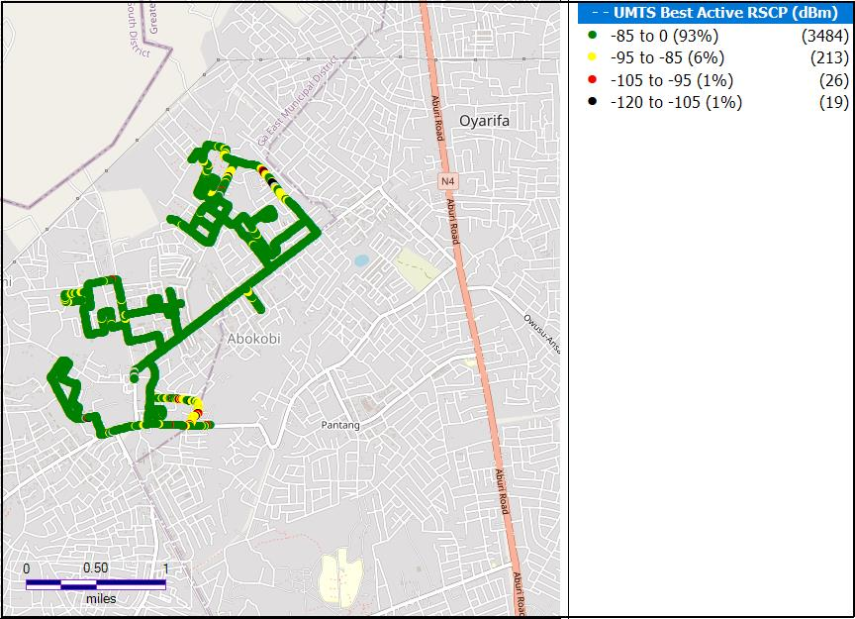

**Remarks:** Good network coverage in Abokobi. However, major network coverage improvement is required around Tiddle PreSchool, Teiman Methodist Church and the Hillview Guest Center.

Figure . 3G Coverage Plot – Adenta

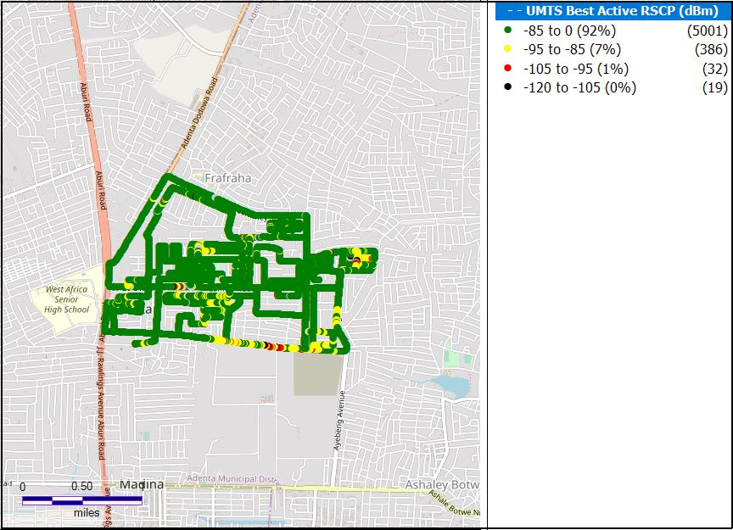

**Remarks:** Good Network Coverage in Adenta. However, major network coverage improvement is needed in areas around Lame Dwaahe Street, Akatamanso Mosque and Rolak Pharmacy.

Figure . 3G Coverage Plot – Amasaman

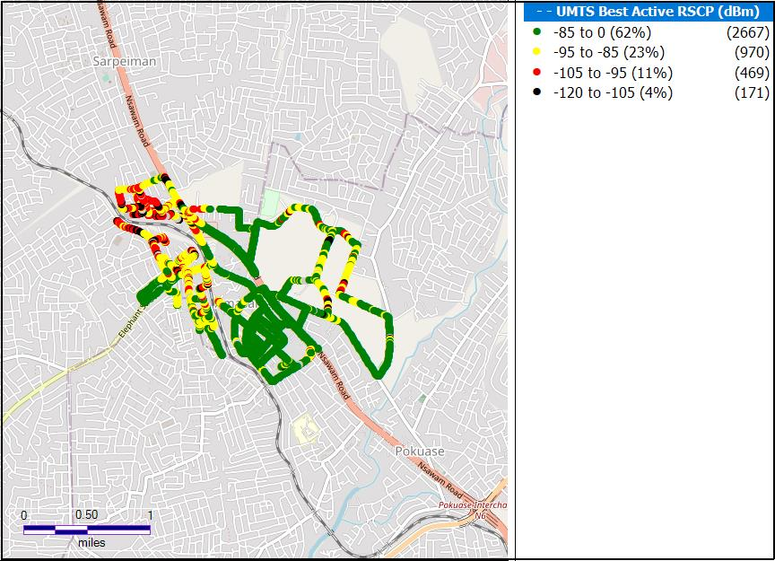

**Remarks:** Good network coverage in Amasaman. However, major network coverage improvement is required around Amasaman Area market, Amasaman Police Divisional headquarters, Kitikri Chop Bar and China Mall.

Figure . 3G Coverage Plot – Dansoman

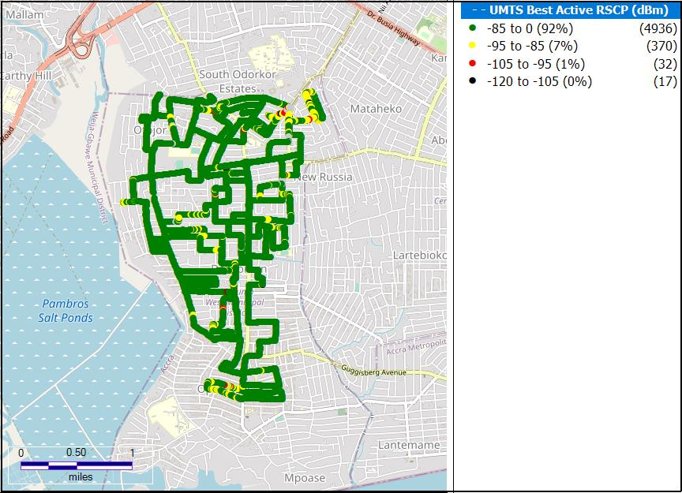

**Remarks:** Good Network Coverage in Dansoman. Minor network coverage improvement is required within the District Capital particular around the Seven Great Princess Academy.

Figure . 3G Coverage Plot – Dodowa

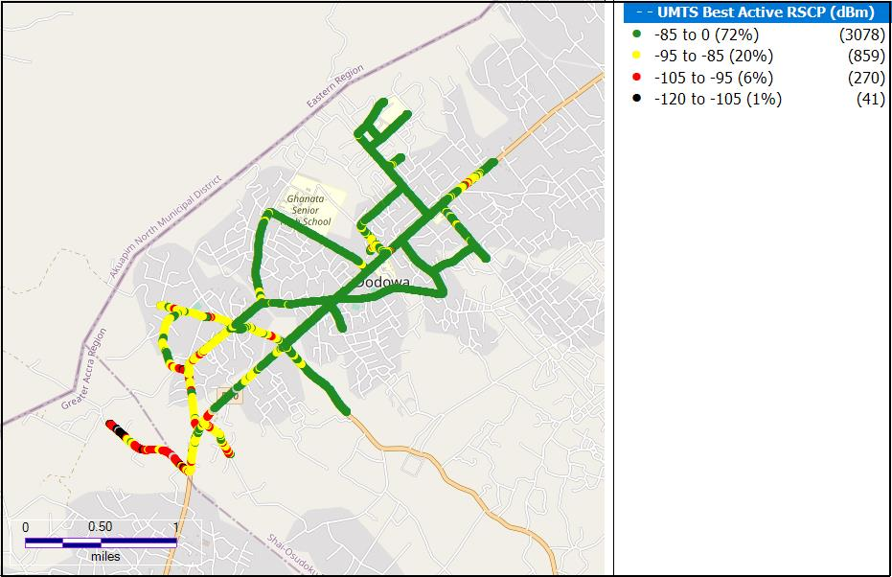

**Remarks:** Good Network Coverage in Dodowa. Major network coverage improvement is required in and around the Dodowa Main Station, Simple Sunflower Lodge and Dodowa Police Station.

Figure . 3G Coverage Plot – Kokomlemle

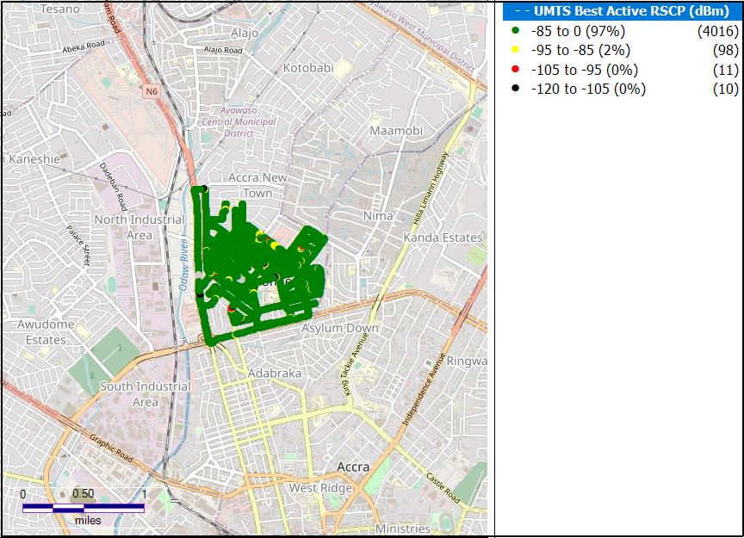

**Remarks:** Good Network Coverage in Kokomlemle. Minor network coverage improvement is required around the Mallam Atta Market.

Figure . 3G Coverage Plot – Kpone

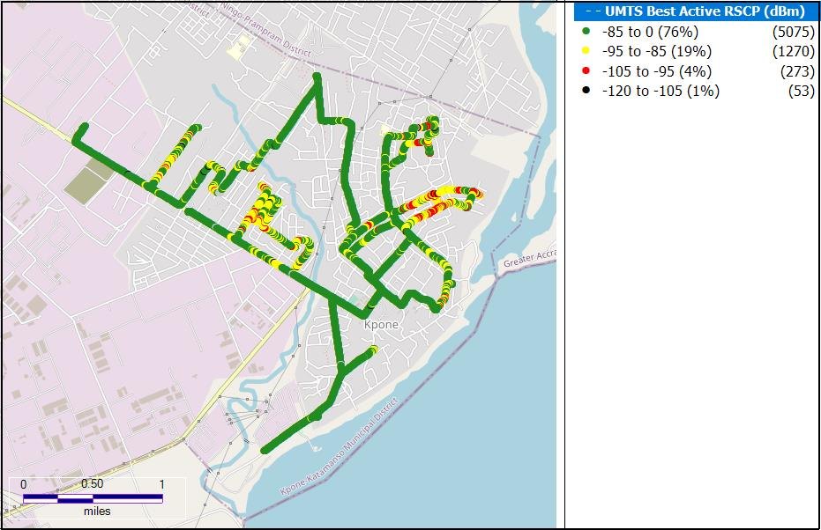

**Remarks:** Good Network Coverage in Kpone. Major network coverage improvement is required in and around the King Solomon Motors, Cinder Pub, Kwamerich Villa and Global Evangelical Agape Chapel.

Figure . 3G Coverage Plot – La

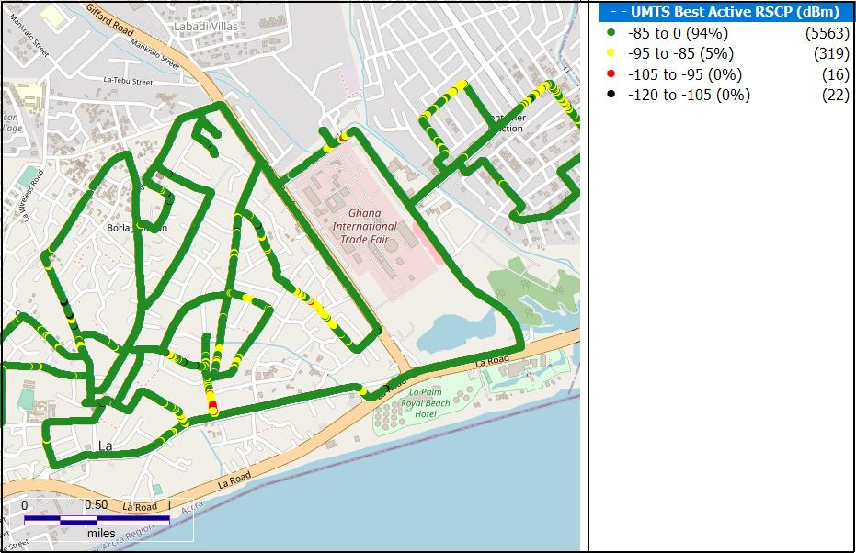

**Remarks:** Good Network Coverage in La. Minor network coverage improvement is required in and around the La Post Office and Paradise Coconut Joint.

Figure . 3G Coverage Plot – Madina

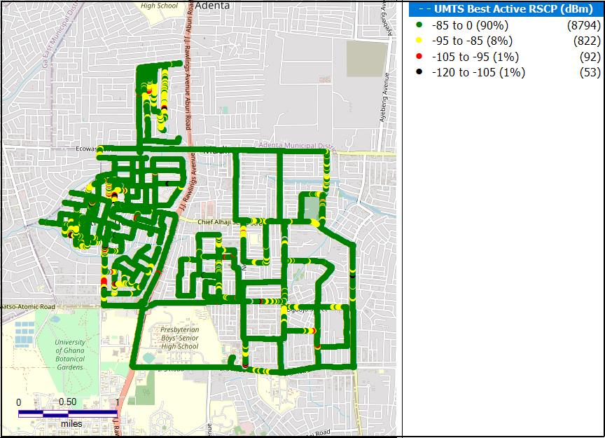

**Remarks:** Good network coverage in Madina. Major network coverage improvement is needed around the Baba Yara Primary and JHS and around the Albany Specialist Clinic.

Figure 10. 3G Coverage Plot **–** Nungua

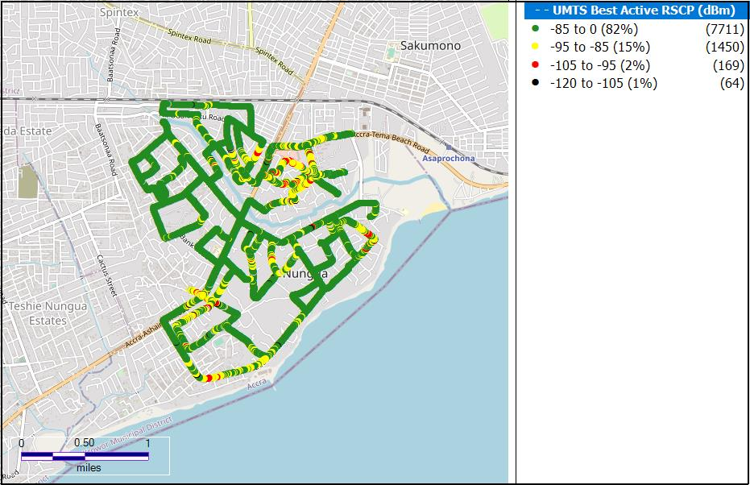

**Remarks:** Good network coverage in Nungua. Major network coverage improvement is required around the Junction Mall, Western portion of the Beach Drive and on the Nautical Street.

Figure 11. 3G Coverage Plot **–** Prampram

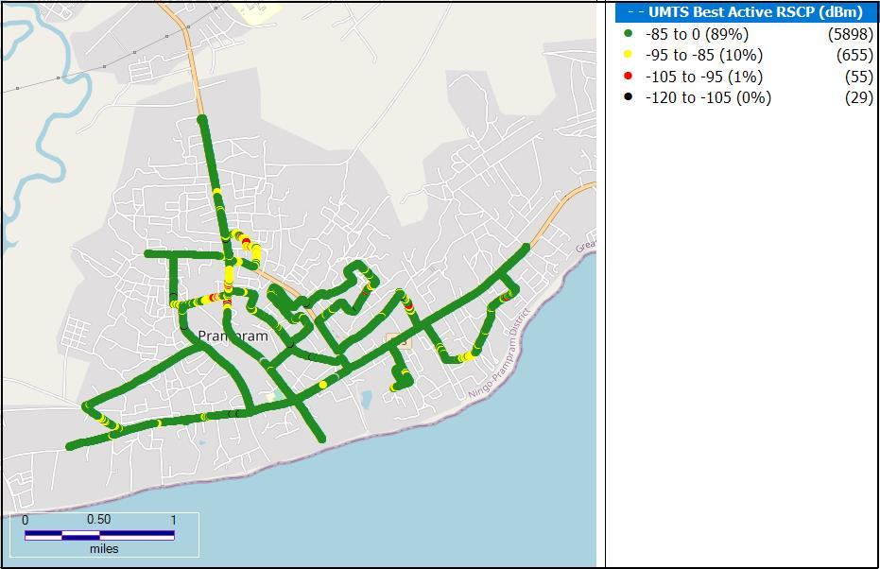

**Remarks:** Good Network Coverage in Prampram. Major network coverage improvement is required around the Ghana Water Company.

Figure 12. 3G Coverage Plot **–** Sege

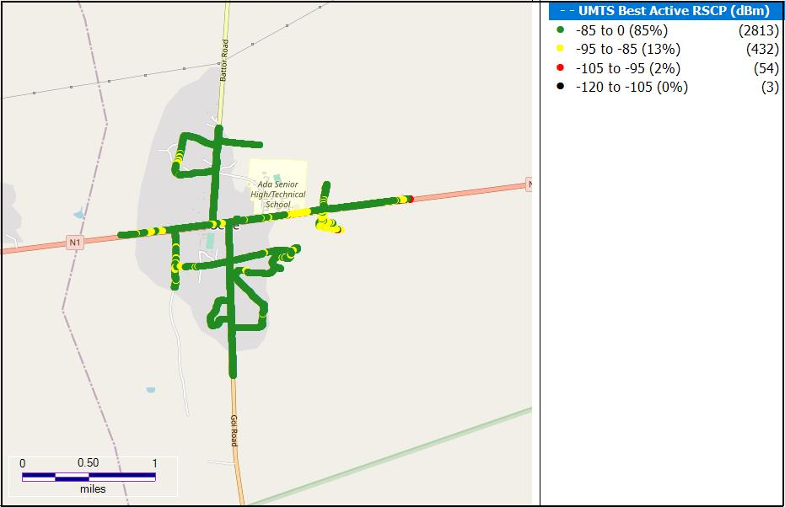

**Remarks:** Good Network Coverage in Sege. Major network coverage improvement is required around the Ada Senior High School.

Figure 13. 3G Coverage Plot **–** Sowutuom

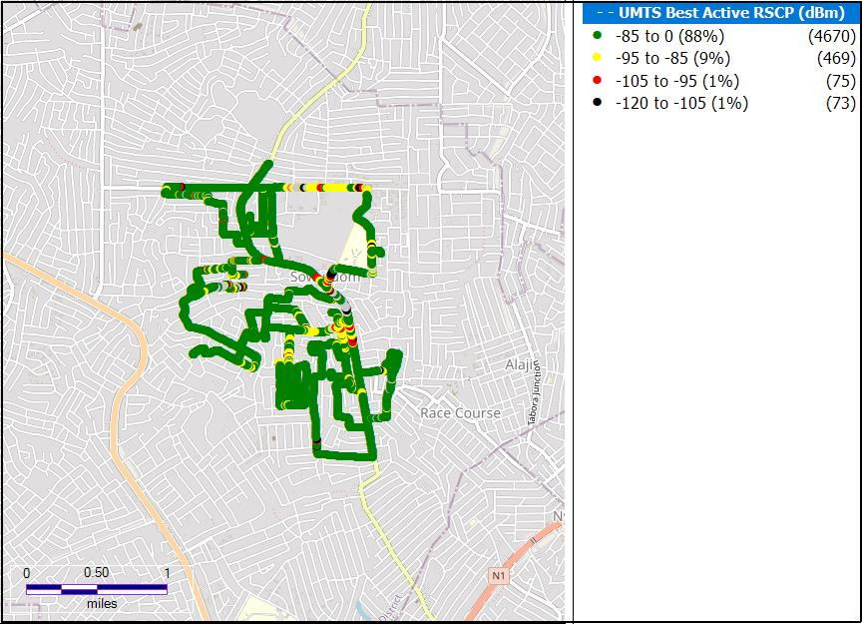

**Remarks:** Good Network Coverage in Sowutuom. Major network coverage improvement is required around the Our Lady of Lourdes Catholic Church, University Drive and Delta Designs.

Figure . 3G Coverage Plot – Tema Community 1

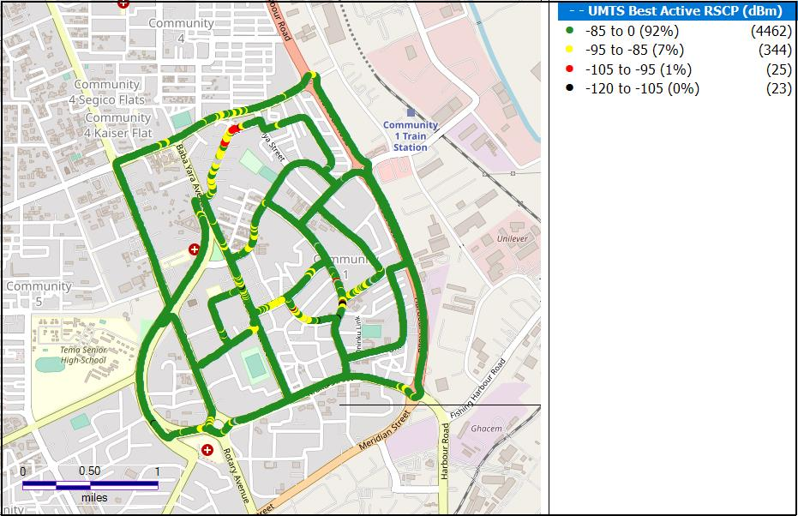

**Remarks:** Good Network Coverage in Tema Community One. Major network coverage improvement is required around the Parkview Plaza on the Krakue Road and around the Kingdom Books and Stationery Limited.

## 1.2.4 RSCP Sampling Distribution

Figure . 3G Coverage Samples Plot

**Remarks**: MTN recorded highest count of RSCP samples in the range –85 ≤RSCP < –20 dBm however, major improvement is required in the 12.35% of samples that are out of Good coverage.

## CONCLUSION

* MTN has 3G coverage in all the fourteen (14) District Capitals tested in the Greater Accra Region.
* MTN requires major 3G coverage improvement in Amasaman, Dodowa and Kpone.